logo-rb-small LSR520/530CPD

1~1000mW Green Laser

**logo-rb-smallFEATURES**

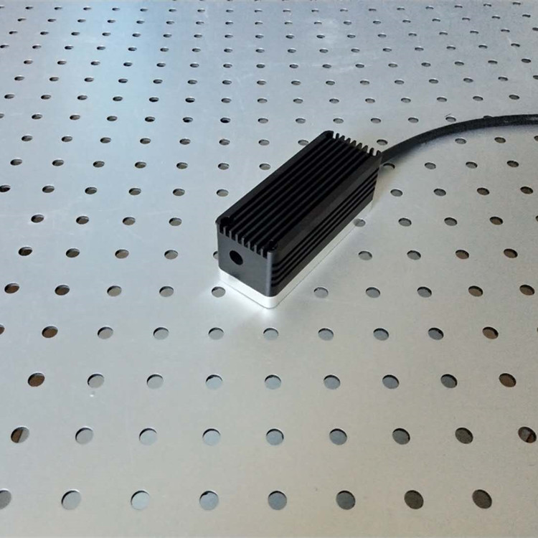 Small Divergence

TEC cooled   
Longlife operation

Analog/TTL modulation

Collimated straight beam  
High efficiency   
High reliability

**APPLICATIONS**

**Laser show**

Display

Laser Alignment

Scanning Biochemistry

Material Inspection Lidar

Specifications

|  |  |
| --- | --- |
| Model No. | LSR520/530CPD |
| Wavelength | 520+/-5 nm |
| Spatial Mode | Near TEM00 |
| Output Power | 800mW，1000mW |
| Operation Mode | CW or Modulation |
| Beam Height | 29mm |
| Beam Size | 4.5x4mm |
| Beam Divergence(full angle) | 1.2x0.5mrad |
| Power Stability | <3% per 4 hrs |
| Temperature Stabilizing | TEC |
| Warm Up Time | <1 minute |
| MTTF | 10,000 hr |
| Laser head dimensions | 114(L)x44(W)x65(H)mm3 |
| Power Supply | A. OEM type  LSR-PS-I: 100(L)x58(W)x32(H)mm3  AC/DC PSU: 85~265V 50/60Hz input |
| B. Lab type  LSR-PS-IIS: 104(W)x128(D)x89(H)mm3  85~265V 50/60Hz input |
| C. Lab Adjustable type  LSR-PS-IIS: 179(W)x148(D)x56(H)mm3  85~265V 50/60Hz input |
| Modulation | 0~30khz Analog or TTL |

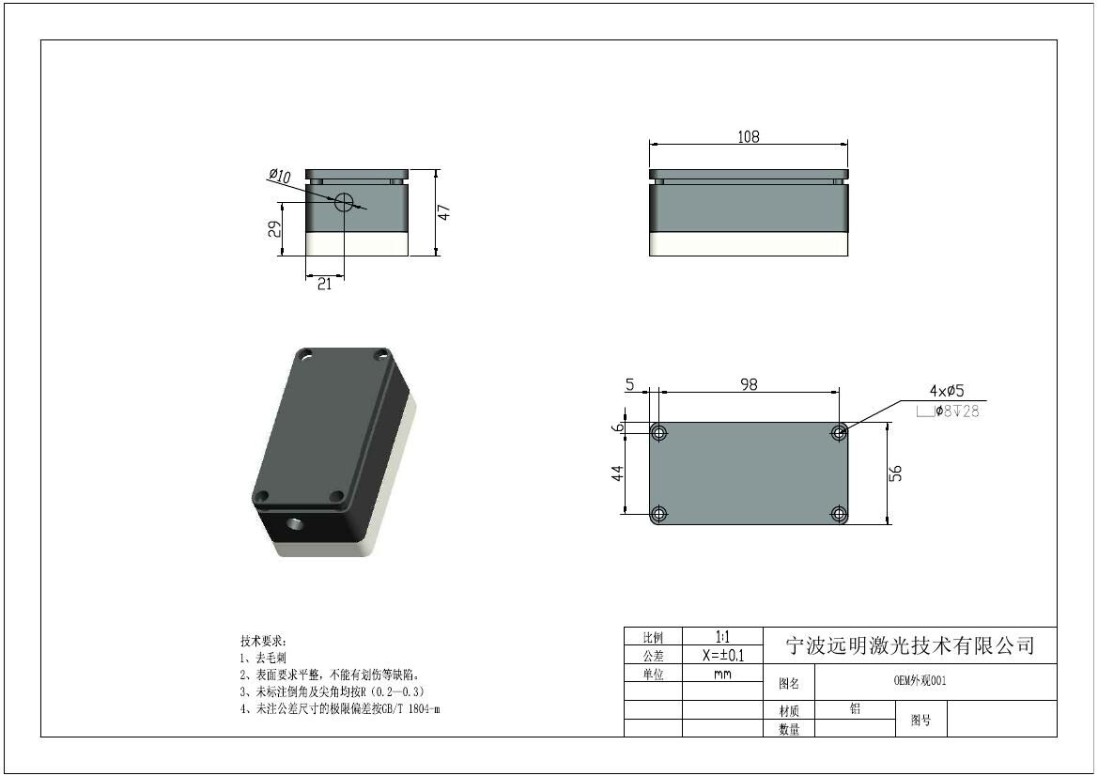

1. Laser with OEM type power supply

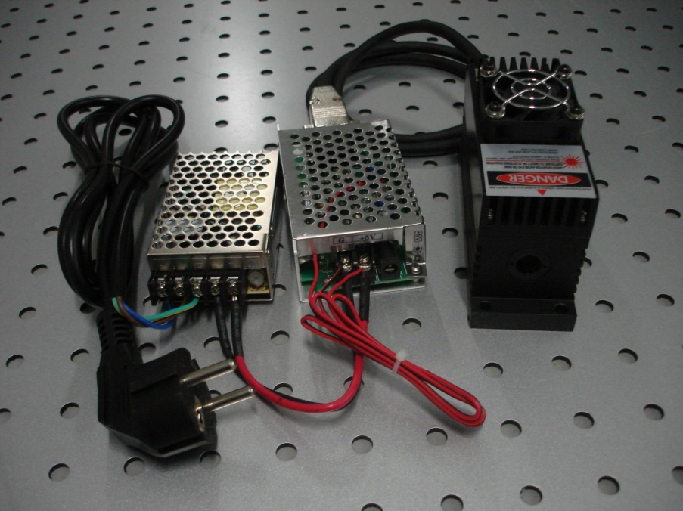

|  |  |
| --- | --- |
| 1. **Lab type power supply**   调整大小 旋转 DSC05832 | **C. Adjustable type power supply**  LSR-PS-II |